Malachite Green Assay

Malachite Green Reagent
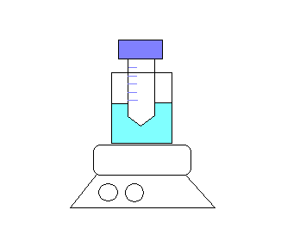
- Malachite green (0.0812% w/v) 50ml
0.0406g in 50ml
- Polyvinyl alchohol (2.32% w/v) 50ml
Take a long time (1hr) to dissolve (need heat)
1.16g in 50ml
- Ammonium heptomolybdate tetrahydrate (5.72% w/v)
2.860g in 50 ml
Mix 1, 2, 3, and ddH₂O in 2:1:1:2 (volume) ratio

Malachite Green Buffer*
100mM Tris Base, 20mM KCl, 6mM MgCl2, pH=7.4

For 500ml buffer:
Tris Base 6.057g
KCl 0.746g
MgCl2 1.22g

→ Adjust pH by HCl (remember to left ~50~100ml space for pH adjust)
- Add 0.01% Triton X-100 immediately before use.

Screening Procedure
- Mix up the enzyme (DnaK or DnaJ + DnaK) anyway you like using MG buffer, but just be sure the total volume of enzyme mix is 15 ul. Usually, 1ug/well of DnaK is used.
- Add 10ul of 2.5mM ATP (diluted by buffer from stock in -80°C) (Remember to make aliquot for the stock, because ATP is easily degraded, not so good if freeze-thaw many times)
- Incubate for 3 hrs in 37°C
- Add 80ul Malachite green reagent
- Immediately after adding Malachite green reagent, add 10ul 32% w/v Sodium citrate to quench nonspecific ATP hydrolysis.
- Incubate in 37°C for 15mins
- Measure OD₆₂₀

